ANNEX B
TO ASDF 11
1. DETAILED REQUIREMENTS OF THE DEDUCTIONS
Following are the deduction items related to the Sri Lanka Army pay process and those can be categorized into four main different categories as mentioned below.
- Common Deductions for all Officer/ OR.
- Common Deductions for Volunteer Officer/ OR.
- When an individual member satisfies the predefined criteria.
- Loan Related.

  - Common Deductions for all Officer/ OR
    - Monthly Fixed Amount

  - W&OP
This deduction applies to all officers and other ranks (ORs) and is calculated as a percentage of their consolidated pay. The monthly deduction rates are:
The following rates are applied after 01.04.2024.
These percentages will be included into the system as a master data with the effective date.
- Officers : 8% of the consolidated pay
- ORs : 8% of the consolidated pay
This amount will be automatically calculated and deducted monthly from the consolidated pay of eligible personnel.

Note: System should provide the provision to calculate W&OP according to two categories:
Category 1 - Based on a given percentage of the consolidated pay amount.
Category 2 - Based on a percentage according to the member type either the Officer/ OR.

  - Sports Found
A monthly deduction of Rs.75 will be made from the salaries of all officers and ORs. The deducted amount will be transferred to the Sports Authority.

  - Religious Fund
A monthly deduction of Rs. 10 will be made from the salaries of all officers and ORs. The amount will be credited to the Army Buddhist Federation.
  - Ranaviru Housing Fund

A fixed monthly deduction will be made from salaries for this fund:
- Officers: Rs. 100.00
- ORs: Rs. 20.00
The collected amounts will be paid to the Directorate of Veterans Affairs.

  - ABF Savings
This is a mandatory monthly deduction applicable to all officers and ORs, credited to the Directorate of ABF. The minimum deduction amounts are as follows:
- Officers : Rs. 3000
- Cadets : Rs. 3000
- ORs : Rs. 2000
For personnel with ABF loans, the minimum monthly deduction for ORs will increase to Rs. 2500.
These minimum amounts should be track as a master data. These amount should obtain from ABF System. If any changes happens to existing savings these changes also taken for each month.
Total deducted amount should transfer to Dte of ABF Account and separate report should generate monthly.

  - Stamp Deductions
A monthly deduction of Rs. 25 will be made from the pay of all officers and ORs from the date of enlistment. This will applicable If gross pay > 25000 (Should be track as a master data) then, stamp deduction amount = 25 (Should be track as a master data). The total amount will be transferred to the Government Income Vote as a cross-entry.

Reporting Requirements:
A monthly report of the transferred deductions.

  - Suwasahana Insurance Fund
A monthly deduction of Rs. 700 will be made from the pay of all officers and ORs after joining the Army. The entire amount will be credited to the Directorate of Welfare (Dte of Welfare). This deduction applies only if the monthly pay is generated, and no arrears recovery will be applied. Total deducted amount should transfer to Dte of Welfare Account and seperate report should generate monthly.
  - Sandahiru Stupa
A fixed amount of Rs. 10 will be deducted monthly from the salaries of all officers and ORs. This amount will be credited to the Ministry of Defense.

  - Multiple Deductions

Deduct from every Officer/OR monthly pay according to the following criteria to the identified sub categories.
- Max amount from officer = Rs. 400 (should be cater as master data)
- Max amount from Cadets = Rs. 290 (should be cater as master data)
- Max amount from Sgt & Above = Rs. 205 (should be cater as master data)
- Max amount from Cpl and L/Cpl = Rs. 155 (should be cater as master data)
- Max amount from Pvt = Rs. 130 (should be cater as master data)

These maximum amount shoud be categorize into following categories.
  - Officer/ cadet Mess - 200 (should be cater as master data)
  - Sports - 30 (should be cater as master data)
  - Religious - 5 (should be cater as master data)
  - Library-5 (should be cater as master data)
  - Salon - 25 (not for Lady Officers/ORs & should be cater as master data)
  - Seva Vanitha - 100/ 10 (100 only for Officers not for cadets/ 10 for ORs not for recruits) (should be cater as master data)
  - Barracks-25 (should be cater as master data)
  - WO & Sgt Mess - 100 (should be cater as master data)
  - Cpl Club - 50 (should be cater as master data)
  - Pvt/ recruit mess - 25 (should be cater as master data)

Multiple deduction amount = RHQ portion + Btn Portion + Other portion (ERE Portion)
(1). If pay location = RHQ
Portion to RHQ = 75% (should be cater as master data) [ for sports, percentage value + Rs10]
Portion to Btn = 25% (should be cater as master data)

(2). If pay Location = Battalion
Portion to RHQ = 25% (should be cater as master data) [ for sports, percentage value + Rs10]
Portion to Btn = 75% (should be cater as master data)
(3). If pay Location! = RHQ or Btn
Portion to RHQ = 25% (should be cater as master data)
Portion to Btn = 25% (should be cater as master data)
Portion to ERE pay location = 50% (should be cater as master data)

Total deducted amount should transfer to the Respective Accounts (RHQ/ Btn/ Mil Establishment) as SLIP in monthly basis and seperate reports should generate monthly.

    - Fixed Amount for entire service duration– monthly based 10 consecutive installments.
  - Legal Aid
A total deduction of Rs. 200 will be made annually from all officers in two installments of Rs. 100 each during January and July. The deducted amounts will be credited to the Directorate of Welfare.

1.1.3 Fixed Amount for entire service duration – one time or until matched the fixed amount
    - Welfare Membership Deductions
This is a one-time deduction of Rs. 1000 applicable to all officers and ORs upon joining the Army. The deducted amount will be credited to the Directorate of Welfare If a member has already paid fully or partially, the deduction date will be retrieved from the existing database. Any outstanding balance will be deducted when the member applies for a loan or welfare item from the Directorate of Welfare.
Reporting Requirements:
- Monthly list of members with deductions
- Monthly list of members without deductions
- Monthly list of deductions from guarantors
Note: More Details of these reports are mentioned in the reporting module.

    - When Notify by the Commander of the Army

- One Day Salary
In exceptional circumstances, the Commander of the Army may authorize the deduction of one day's consolidated salary (1/30th) from officers.
Details to Note:
- The total amount deducted should be transferred monthly to the SLAVF Account.
- Separate reports must be generated monthly to record these transactions. (More Details of these reports are mentioned in the reporting module.)

    - Annually Fixed Amount – 2 installments (predefined 2 months)

  - Death Donation Fund
A total deduction of Rs. 200 will be made annually from all officers in two installments of Rs. 100 each during January and July. The deducted amounts will be credited to the Directorate of Welfare.

    - Annually Fixed Amount (one time)
  - Ex-Servicemen
This annual deduction supports ex-servicemen initiatives.

Deduction Amounts:
  - Rs. 25.00 for officers
  - Rs. 10.00 for other ranks
Process: The collected amounts will be transferred to the HQ Battalion.
  - Small Arms Society
This annual deduction contributes to the Small Arms Society fund.
Deduction Amounts:
  - Rs. 6.00 for officers
  - Rs. 3.00 for other ranks
Process:
  - Deductions will be credited to the Small Arms Fund of the MSTS (Marksmanship Training School).
  - Total amounts will be transferred monthly.
Reports:
Monthly reports should include the deducted member list and total contributions.

    - Monthly Variable
    - Cent Deduction (Balance Cents)
This deduction applies to any remaining cents in the salary balance of individuals. The collected amount will be credited to the Commander of the Army’s account.
Cent deduction amount = Round off Net pay value - net pay before round off
    - Mess Bill Deduction
Monthly deductions will be made from officers' salaries for facilities provided at approved official residences.
Details:
  - Amounts collected from respective residences will be deposited into the residence’s account.
  - All details must be recorded on Form AFP 23.
Pay Slip Display:
  - Mess bill deductions will be shown as a separate entry under the total salary on the salary sheet.
  - Total restaurant bills will appear as a distinct entry in the deductions section.
Process:
A consent declaration from the residence must be included and recorded on the form during data entry.
c. Unit Deduction
Monthly deductions will be made from ORs’ salaries based on the amounts provided by the respective battalions. A separate interface should be provided at the battalion level to upload the data in an Excel format. The specified Excel format should be shared with the battalions in advance.
  - Ser No
  - Reg No
  - Rank
  - Name
  - Regiment
  - Battalion
  - Amount
The total deducted amount should be transferred to the respective Battalion PRI accounts on a monthly basis as an SLIP payment.

d. Meal Deduction
Applicability:
Deductions for meals provided to ORs, based on amounts from the Ration Management System or ration locations.
Interface for Data Upload:
- Data to be uploaded via a dedicated interface in an Excel format.
- Required fields:
(a) Serial No.
(b) Reg No.
(c) Rank.
(d) Name.
(e) Regiment.
(f) Battalion.
(g) Amount.
Transfer of Funds:
Deducted amounts are transferred monthly to the Dte of S&T vote via a cross entry.
Reports:
Monthly reports documenting total deductions and transfers.

2. COMMON DEDUCTION FOR VOLUNTEER OFFICERS/ ORS
2.1 From Very First Salary – One Time for Entire Service
a. One day Salary of Volunteers
One day’s salary (Consolidated Pay × 1/30) will be deducted from the first salary of all volunteer officers and ORs.
Details to Note:
- The total amount deducted should be transferred monthly to the SLAVF Account.
- Separate reports must be generated monthly to record these transactions.

3. WHEN AN INDIVIDUAL MEMBER SATISFIES THE PREDEFINED CRITERIA
3.1 Monthly
a. Liberty Charges
A monthly deduction of Rs. 350 will be made from the pay of senior officers appointed as Brigadiers. The amount will be credited to the government’s revenue account.
Note: should calculate Propotionately from the Brigadier confirmed date for the first deduction and the final deduction prior to pension.

b. Married Quarter deduction
Eligibility & Conditions:
Applicable to officers and ORs occupying married quarters, excluding those with recognized appointments (e.g., COS in Quarter No. CD 92). Exceptions must be maintained as master data.
Deduction starts upon publication of the Part II Order for occupying the married quarters and stops upon publication of the Part II Order for handover or initiation of penal deductions for unauthorized use.
Deduction Calculation:
Married Housing Deduction Amount = minimum of:
- 10% of Consolidated Pay, or
- Economic Rent of the specific quarter.
Economic Rent values should be maintained as master data by the Directorate of Real Estate and Quarters (Dte of RE&Q) with effective dates.
Impact on Rent Allowance:
- Rent allowance stops once the Part II Order for occupying married quarters is published.
- Arrears should be calculated based on the effective date of occupancy as per the Part II Order.
Transfer of Funds:
Deducted amounts are transferred monthly to the Government Income Vote via a cross-entry.
Notifications:
The respective battalion should be notified of any Part II Order publications.
Reports:
Monthly reports for deductions, transfers, and arrears calculations.
c. Bank Deposit
Upon request, members of the armed forces can request for a monthly transfer of a specified amount to another account they own. The amount needs to deduct from Officers / ORs monthly pay who is willing to deduct money from monthly pay and deposit to another bank account except the salary paid account owned by him/her self.
Following information should provide via AIPS interface from battalion level/ respective pay group:
Details to Provide via AIPS Interface:
  - O/Reg Number
  - Name
  - Rank
  - Regiment
  - Battalion
  - Bank
  - Branch
  - Account type (Savibala Savings, any special agreed savings, Normal bank deposit)
  - Account No
Special Report Requirements:
- If the account type is Savibala Savings at NSB, a separate report with member details and savings amounts must be sent to the MOD.
- For special agreed account types, separate reports must also be prepared.

Compulsory Savings
This special deposit scheme is a collaboration between the National Savings Bank and the Army, encouraging members to save with favorable interest rates and fixed deposit terms.
Details:
  - Participation is voluntary.
  - Monthly credits to the relevant NSB branch based on the member’s chosen deposit amount.
  - All details must be recorded on Form AFP 23.

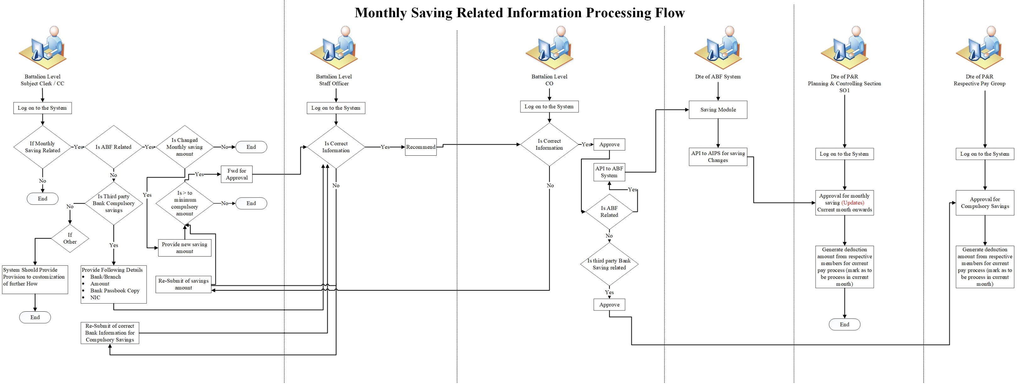

d. Panel Married Housing
Applicability: Applies when the authority period for married quarters indicated at the Married Quarters Part II Order (4 years) expires and no extension or handover has been arranged.
Deduction Calculation:
- Penal Married Housing Deduction Amount = (Consolidated Pay × 8%) + Market Rent Value.
- Market Rent Value must be maintained as master data by the Dte of RE&Q with effective dates.
Transition:
Regular married quarters deductions cease when penal deductions begin.

Conditions to Stop Deductions:
Deductions stop once the Part II Order for extension or handover is published.

Transfer of Funds:
Total deductions are transferred monthly to the Government Income Vote as a cross-entry.
<
Reports:
Monthly reports detailing penal deductions, transfers, and unresolved cases.

e. KDU Married Housing
Eligibility:
- Officers occupying married quarters at the Kotelawala Defence University (KDU).
- No AFA 09 form is issued for this case.
Process:
- Housing rent allowance stops upon notification from the university.
- A 15% deduction from the officer's consolidated salary is applied.
Receipts & Reporting:
- The system should generate a disbursement slip for this deduction.
- Total deductions are transferred monthly to the KDU Account via cheque.
- Monthly reports documenting these transactions must be generated.

3.2 At the Time of Satisfy the Criteria
a. Overseas Stamp Deductions
Eligibility:
- Officers or ORs who receive a total overseas allowance exceeding Rs. 25,000 are subject to this deduction.
- The allowance threshold of Rs. 25,000 and the deduction amount of Rs. 25 must be maintained as master data.
Approval Process:
The total overseas allowance and the relevant overseas duration must be approved by the Overseas Section of the Directorate of Pay and Records (Dte of P&R).
Deduction Process: A fixed amount of Rs. 25 is deducted from the monthly pay of eligible personnel.
Fund Allocation: The total deducted amount is transferred to the Government Income Vote as a cross-entry on a monthly basis.
Reports: Monthly Reports should include:
  - List of members subject to the deduction.
  - Total deduction amounts.
  - Confirmation of fund transfers to the Government Income Vote.
Pay Slip Display:
The deduction will appear as Overseas Stamp Deduction in the pay slip under the deductions section.

b. Dialog Connections Fees
For individuals who have obtained Dialog SIM cards via the Operations Branch, the corresponding fees will be deducted from their salaries and credited to Dialog.

Details:
All transaction details must be recorded on Form AFP 23.
c. Advance Personal Income Tax
Based on the data provided below, this deduction will be made, and the collected amounts should be transferred to the Department of Inland Revenue. Additionally, the income tax due from the officer for the respective year, covering the period from the 1st of April of the previous year to the 31st of March of the current year, should be processed annually according to the request format issued by the Department of Inland Revenue.
The allowances (Financial benefits) to be considered for the deduction of taxes are as follows.
- Consolidated Pay
- Qualification Pay
- Incentive Allowance
- Cost of Living
- Executive Allowance
- Budget Allowance
- Interim Allowance
- Engineering/Architect/Survey Allowance
- Legal Allowance
- Chartered Engineering/ Chartered Architect Allowance

For Medical officers all above nine allowances and the following allowances will be considered for the deduction of taxes.
Allowances which considered only for Medical Officers.
- Service Allowance
- Pensionable Allowance
- Non Pensionable Allowance
- Special Service Allowance
- Language Allowance I & II
- 1/20 Allowance
- DAT
- Extra Duty Allowance
- Veterinary Allowance
In addition to above allowances, following non-financial benefits which are considered for the deduction of taxes. These non-financial benefits will value in different way for the different person categories.

- Staff Vehicle
- Drivers
- Buddies

The method for calculating
(1) if (Consolidated Pay + Cost of Living + Interim Allowance + Q Pay + Executive Allowance + Engineering Allowance + Incentive Allowance + additional allowance + leagal allowance + Total of Non-financial benefits) < 100000 => no any tax
(2) if (Consolidated Pay + Cost of Living + Interim Allowance + Q Pay + Executive Allowance + Engineering Allowance + Incentive Allowance + additional allowance + leagal allowance + Total of Non-financial benefits) > 100000 and <= 141,667 =>
Tax amount = (Consolidated Pay + Cost of Living + Interim Allowance + Q Pay + Executive Allowance + Engineering Allowance + Incentive Allowance + additional allowance + leagal allowance + Total of Non-financial benefits) * 6/100 - 6000
(3) if (Consolidated Pay + Cost of Living + Interim Allowance + Q Pay + Executive Allowance + Engineering Allowance + Incentive Allowance + additional allowance + leagal allowance + Total of Non-financial benefits) > 141668 and < =183333 =>
Tax amount = (Consolidated Pay + Cost of Living + Interim Allowance + Q Pay + Executive Allowance + Engineering Allowance + Incentive Allowance + additional allowance + leagal allowance + Total of Non-financial benefits) * 12/100 - 14500
(4) if (Consolidated Pay + Cost of Living + Interim Allowance + Q Pay + Executive Allowance + Engineering Allowance + Incentive Allowance + additional allowance + leagal allowance+ Total of Non-financial benefits) > 183334 and < =225000 =>
Tax amount = (Consolidated Pay + Cost of Living + Interim Allowance + Q Pay + Executive Allowance + Engineering Allowance + Incentive Allowance + additional allowance + leagal allowance + Total of Non-financial benefits) * 18/100 – 25500
(5) if (Consolidated Pay + Cost of Living + Interim Allowance + Q Pay + Executive Allowance + Engineering Allowance + Incentive Allowance + additional allowance + leagal allowance + Total of Non-financial benefits) > 225001 and < =266667 =>
Tax amount = (Consolidated Pay + Cost of Living + Interim Allowance + Q Pay + Executive Allowance + Engineering Allowance + Incentive Allowance + additional allowance + leagal allowance + Total of Non-financial benefits) * 24/100 - 39000
(6) if (Consolidated Pay + Cost of Living + Interim Allowance + Q Pay + Executive Allowance + Engineering Allowance + Incentive Allowance + additional allowance + leagal allowance + Total of Non-financial benefits) > 226668 and < =308333 =>
Tax amount = (Consolidated Pay + Cost of Living + Interim Allowance + Q Pay + Executive Allowance + Engineering Allowance + Incentive Allowance + additional allowance + leagal allowance + Total of Non-financial benefits) * 30/100 - 55000
(7) if (Consolidated Pay + Cost of Living + Interim Allowance + Q Pay + Executive Allowance + Engineering Allowance + Incentive Allowance + additional allowance + leagal allowance + Total of Non-financial benefits) > 308334
Tax amount = (Consolidated Pay + Cost of Living + Interim Allowance + Q Pay + Executive Allowance + Engineering Allowance + Incentive Allowance + additional allowance + leagal allowance + Total of Non-financial benefits) * 36/100 – 73500

d. Welfare Donations
A monthly deduction will be made for welfare donations from the pay of all officers and ORs in the current month's pay strength.
Deduction Amount:
Maximum per individual: Rs. 50.00 (maintained as master data).
Formula:
If Total Donated Amount / Total Pay Strength≤50\text{Total Donated Amount / Total Pay Strength} \leq 50Total Donated Amount / Total Pay Strength≤50:
Welfare Donation Amount=Total Donated Amount / Total Pay Strength\text{Welfare Donation Amount} = \text{Total Donated Amount / Total Pay Strength}Welfare Donation Amount=Total Donated Amount / Total Pay Strength
If Total Donated Amount / Total Pay Strength>50\text{Total Donated Amount / Total Pay Strength} > 50Total Donated Amount / Total Pay Strength>50:
Welfare Donation Amount=50\text{Welfare Donation Amount} = 50Welfare Donation Amount=50 and
Carry Forward Amount=Total Donation - (50 × Total Pay Strength)\text{Carry Forward Amount} = \text{Total Donation - (50 × Total Pay Strength)}Carry Forward Amount=Total Donation - (50 × Total Pay Strength).
Pay Slip Display:
Recipients and corresponding donated amounts will be displayed in the latter section of the pay slip for all pay strength members.
Process:
  - Donor and recipient details will be submitted to the Dte of P&R via a Board report.
  - The Planning and Controlling section at the Dte of P&R will input data into the AIPS system.
  - SO I at Dte of P&R will review and approve entries.
  - If the total deduction is less than the donation, the balance will be carried forward to the next month.
Reports:
Total deducted amounts will be transferred monthly to PRI accounts of relevant RHQs.
Monthly reports will include:
    - Deduction summary
    - Carry forward amounts
    - Recipient details
e. MISC Deduction One Time
Applicability:
  - A one-time deduction based on decisions by COI/COA.
  - Each decision must include references, respective dates, and the declared amount.
Deduction Process:
Amount = Declared amount per decision.
Captured details include: Reference number and date of decision.
Transfer of Funds:
Deducted amounts are transferred to the respective receiver accounts monthly as SLIP payments based on mappings prepared by the SO1 at the Dte of P&R (Planning and Controlling Section).
Reports:
Monthly reports detailing deductions and transfers.

f. Regimental Death Donation Found
This deduction facilitates the recovery of amounts provided to regiments in the event of deaths.
Special Consideration: Officers serving in the Special Forces will have the relevant amounts documented and submitted for appropriate deductions.

3.3 Based on the Predefined no. of installments

a. MISC Deduction Installment
Applicability:
- Installment-based deductions as per COI/COA decisions.
- Captured details: Decision reference, date, total amount, installment amount, and number of installments.
Deduction Process:
Amount = Declared installment amount per decision.
Display in the Pay Slip:
  - Balance amount.
  - Remaining installments.
  - Relevant authority references displayed at the bottom.

Transfer of Funds:
Deducted amounts are transferred monthly to the respective receiver accounts as SLIP payments based on mappings by the SO1 at the Dte of P&R.
Reports:
A separate report listing due amounts, remaining balances, and installment counts.

4. LOAN RELATED
4.1 Dte of ABF
a. ABF Loan installment
This deduction applies to officers and ORs who have taken loans from the Directorate of ABF. The monthly deduction amount will be forwarded from the Dte of ABF to the Dte of P&R.
Reporting Requirements:
- Monthly list of members with deductions
- Monthly list of members without deductions
- Additional reports as required
Note: meaningful item name should be displayed in the pay slip according to different loan types (to display remaining balance)
Format: ABF installment - 85%

b. ABF Loan Interest
Deduct from Evry Officer/ OR if they already obtained loan from Dte of ABF. Deduction interest amount (Monthly interest, loan type) will received via API from ABF System. Balance amount should be included to the individual loan summary report while integrate with Dte of ABF System.
Total deducted amount should transfer to Dte of ABF Account and following reports should generate monthly and transfer via API to ABF System.
      - Monthly deducted member list
      - Monthly not deducted member list
(Note : Blance amount/ Balance Installment should be displayed in the bottom part of the pay slip with the relevant loan type and the interest rate, Loan reference No) Meaningful item name should be displayed in the pay slip according to different loan types.
Format : ABF interest - 85%

c. Suwasahana Loan Installment
Monthly deductions will be made from the pay of officers and ORs who have received Suwasahana Loans. The deduction amount, outstanding balance, and remaining installments will be forwarded from the Suwasahana Loan Section to the Dte of P&R.
Reports to be Generated:
- Monthly list of members with deductions, including interest levels
- Monthly list of members without deductions, including interest levels
- Additional reports as required
- Tracked Information for Loan Management:
- O/Reg Number
- Name
- Rank
- Regiment
- Battalion
- Loan Amount
- Interest Rate
- Number of Installments
- Loan Disbursed Date
- Installment Amount
- Loan Repayment Start Date
- Loan Repayment End Date
- Loan Reference Number
Pay Slip Display:
- For loan owners: Suwasahana Installment
- For guarantors: Suwasahana Installment (Guarantor)
The balance amount and remaining installments will be displayed at the bottom of the pay slip along with the loan type, interest rate, and loan reference number. This information will also appear in the member-wise loan summary report.

d. Suwasahana Loan Interest
This deduction applies to officers and ORs who have received Suwasahana Loans. The interest amount will be deducted monthly from their pay based on information forwarded by the Suwasahana Loan Section to the Dte of P&R.
Reports to be Generated Monthly:
- List of members with deductions and interest levels
- List of members without deductions and interest levels

Pay Slip Display:
- For loan owners: Suwasahana Interest – [Interest Rate]% (e.g., Suwasahana Interest – 9%)
- For guarantors: Suwasahana Interest – [Interest Rate]% (Guarantor) (e.g., Suwasahana Interest – 9% (Guarantor))

The remaining balance and outstanding installments will also be indicated on the pay slip.

4.2 Dte of Welfare
a. Welfare Loan/Item Deduction
If an officer or an OR purchases goods or avails of loans through the Directorate of Welfare , the relevant installment amount will be deducted monthly as per the terms outlined by the Directorate of Welfare. The deductions will be transferred to the Welfare Directorate account and recorded in the loan summary.
Types of Welfare Loans/Items
- Goods/Items: CIB and Other Shops
- Finance Loans:
- Rs. 100,000
- Rs. 300,000
- Air Ticket Loan – Rs. 300,000
- CIB Loan – Rs. 25,000
Note : Balance amount/ Balance Installment should display in the bottom part of the pay slip with relevant loan type and the interest rate.

For transparency, the following naming conventions will be used on pay slips:
If the pay slip owner is the loan owner: Welfare Loan – [Loan Type/Amount] (e.g., Welfare Loan – 100000).
If the pay slip owner is a guarantor: Welfare Loan – [Loan Type/Amount] (Guarantor) (e.g., Welfare Loan – 100000 (Guarantor)).
(Format of the excel sheet should be provided to the Dte of Welfare)

- ENo
- Name
- Rank
- O/Reg No
- Unit
- Regiment
- Loan/ Item Type
- Obtained Amount
- Loan/ Item received date
- Installment
- ref No
Gurantor details (ENo, O/Reg No, Name, Rank, Unit, Regiment).
Guarantor activate/deactivate criteria should include in the document
Total deducted amount should transfer to Dte of Welfare Account and seperate report should generate monthly.
This should be incliuded in member wise Loan summary report.

4.3 Dte of P & R

a. Advanced B Account Related Loans
Monthly deductions will be made from the salaries of Officers and ORs who have taken loans under the Government Advanced B Account.
Details to Provide via AIPS Interface:
  - O/Reg Number
  - Name
  - Rank
  - Regiment
  - Battalion
  - loan type (property loan, Festival Advance, Special Advance, Distress)
  - No. of Installments
  - Loan Disbursed Date
  - Installment amount
  - Loan Repayment Start Date
  - Loan Repayment End Date
  - Loan reference No
Process:
- Initial deduction starts after approval by the Loan Section OC and Accountant at the Directorate of P&R.
- 'To be Paid' member list is generated automatically based on allocated loan funds.
- Monthly deductions continue automatically until loan repayment is complete.

Monthly Reports:
  - Monthly deducted member list (with Owner/Guarantor details).
  - Monthly not deducted member list (with reasons).
  - Long-term not deducted member list (e.g., 6/12/18 months).
  - Additional reports as required.

Types of Loans Under Advanced B Account
(1) Property Loan
(1). Installment with relevant interest deductions for property loans will be credited to the relevant bank account as per loan documents.
(2). If issued through the government’s Guarantee B account, it must be recorded in the loan summary.
(2) Festival Advance
(1). Deductions for personnel receiving festival advances will be credited to the advanced account (Account B) to ensure settlement.
(3) Special Advance
(1). Special advances for school books for ORs’ children will be deducted with relevant interest and credited to Advanced B account for settlement.

(4) Distress Loan
(1). Monthly deductions with relevant interest for distress loans will include remaining balances and outstanding installments in reports.
Pay Slip Display:
- For loan owners: Distress Loan Installment.
- For guarantors: Distress Loan Installment (Guarantor).

b. P&R PRI Loan Deduction

Loan deductions will be made for members who have obtained loans through P&R PRI.
Details:
  - Total loan amount
  - Installment amount
  - Number of installments
  - Guarantor details
  - Loan disbursement date
  - Loan repayment start date
  - Loan repayment end date
Pay Slip Display:
  - Loan Owner: P&R PRI Loan
  - Guarantor: P&R PRI Loan (Guarantor)
Process:
  - Loan details will be uploaded by the P&R PRI Section OC.
  - Monthly deductions continue until the loan is fully repaid.
Reports:
  - The total deducted amount is transferred monthly to the P&R PRI Account.
  - Monthly reports to include:
(a) Deducted member list
(b) Not deducted member list
(c) Outstanding balances and installments
4.4 Third party financial organization related
a. Insurance

This deduction applies to officers and ORs who have life insurance coverage through the Army. The insurance installment amount will be sent by the respective insurance company to the Dte of P&R and credited to the insurance company’s account.

Pay Slip Display:
- Insurance – Life
- Insurance – Arunalu
- Insurance – [Other Company Name]
- Arrears recovery will be applied if necessary.

ARUNALU INSURANCE
The Arunalu Insurance deduction will be deducted from the officers and ORs who have Arunalu insurance coverage obtained through the Army from Life Insurance Coordination Lanka Limited. The insurance installment amount will be sent from the respective insurance company to the Dte of P&R and then the deducted amounts will be credited to Life Insurance Coordination Lanka Limited.

b. Bank Loan Deduction
This deduction applies to individuals who have received loans under FR 238(5). Installments will be deducted based on the details provided by the respective bank.
      - O/Reg Number
      - Name
      - Rank
      - Regiment
      - Battalion
      - Bank
      - Branch
      - Loan type (Bank Loan, Viru Abiman, Special agreed loan from agreed bank, Property Loan - Bank)
      - Loan Amount
      - Interest rate
      - No. of Installments
      - Loan Dispursed Date
      - Installment amount
      - Loan Repayment Start Date
      - Loan Repayment End Date
      - Loan reference No

Note:
- Recovery begins upon approval by the pay group officer after the bank’s loan disbursement letter is received.
- Adjustments for partial or full settlement can be made based on bank information.

Pay Slip Display:
[Loan Type] Loan (e.g., Normal Loan, Viru Abiman Loan)

VIRU ABHIMANA LOAN INSTALLMENT
Loan installments under this scheme will be deducted monthly from the salaries of all eligible individuals and paid to the respective bank. Details will be recorded on Form AFP 23.

c. Lady Lochore Deduction
This deduction applies to individuals with loans under the Lochore Loan Scheme. Monthly installments will be deducted, and the remaining balance and outstanding installments will be displayed.
If the Lady Lochore Fund provides necessary details to deduct the loan amount from the guarantor instead of the owner due to a prolonged stoppage of deductions, these modifications should be made by the respective pay group officer.

Pay Slip Display:
- For loan owners: Lochore
- For guarantors: Lochore (Guarantor)
Details will be recorded on Form AFP 23.

d. RANAVIRU SEVA AUTHORITY
Under this loan scheme, monthly deductions will be made from the salaries of individuals who have received loan funds. These amounts will be paid to the Ranaviru Services Authority.

Details to be Recorded:
- Current loan balance
- Number of future installments to be collected
- All details should be recorded on Form AFP 23 and noted in the salary statement and loan summary.

Pay Slip Display:
- For loan owners: Ranavirusewa Authority Loan
- For guarantors: Ranavirusewa Authority Loan (Guarantor)

e. NHDA Loan Deduction
This loan deduction applies to individuals with loans from the National Housing Development Authority (NHDA). Installments will be deducted monthly and paid to NHDA branches.
Details to be Recorded:
- Current loan balance
- Number of future installments to be collected
- All details should be recorded on Form AFP 23 and noted in the salary statement and loan summary.

Pay Slip Display:
- For loan owners: NHDA Loan
- For guarantors: NHDA (Guarantor)

f. Seva Wanitha Housing Loan
Under this loan scheme, installments will be deducted monthly from the salaries of officers who have received funds under the loan. The deductions will be transferred to the Ministry of State Security.
Details to be Recorded:
- Current loan balance
- Number of future installments to be collected
- All details must be recorded on Form AFP 23, included in the salary statement, and tracked in the loan summary.
Pay Slip Display:
- For loan owners: Army Seva Wanitha Loan
- For guarantors: Army Seva Wanitha Loan (Guarantor)

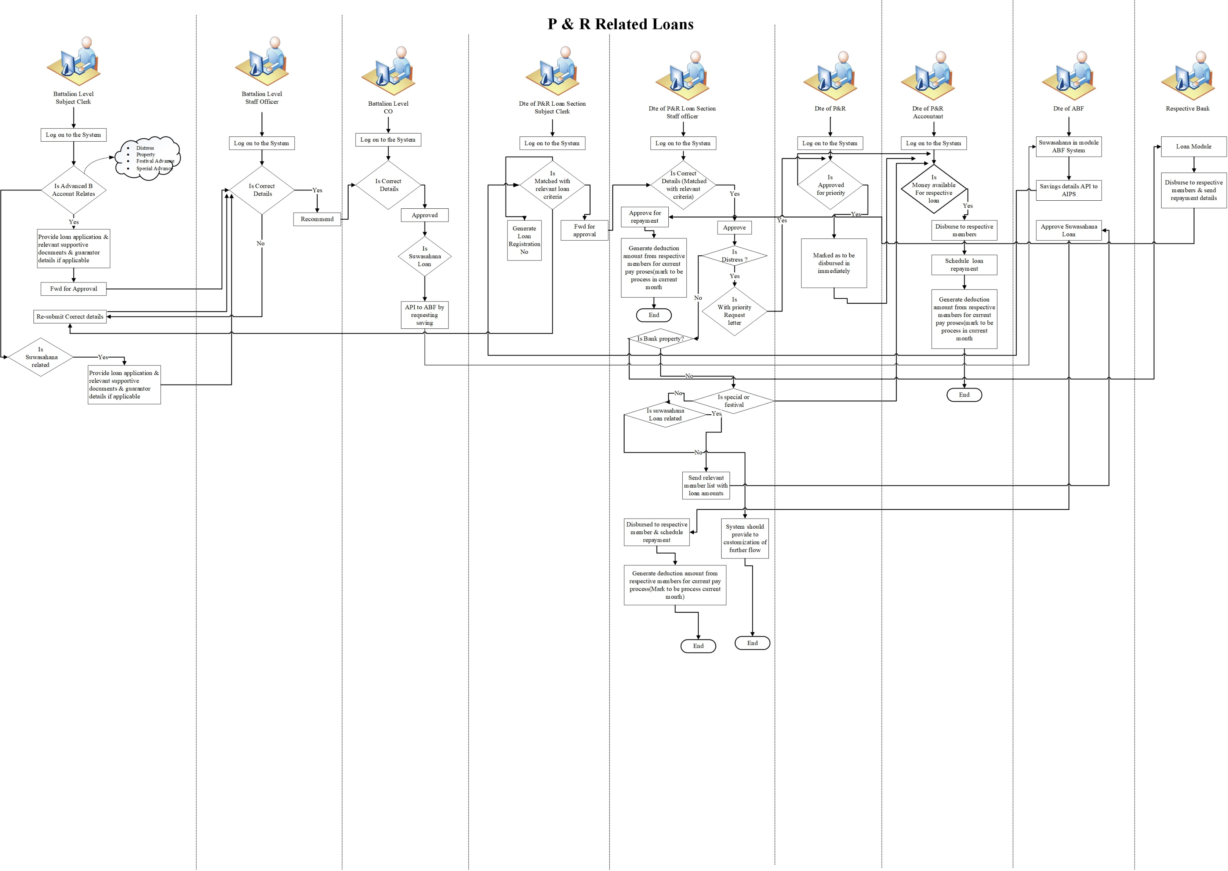

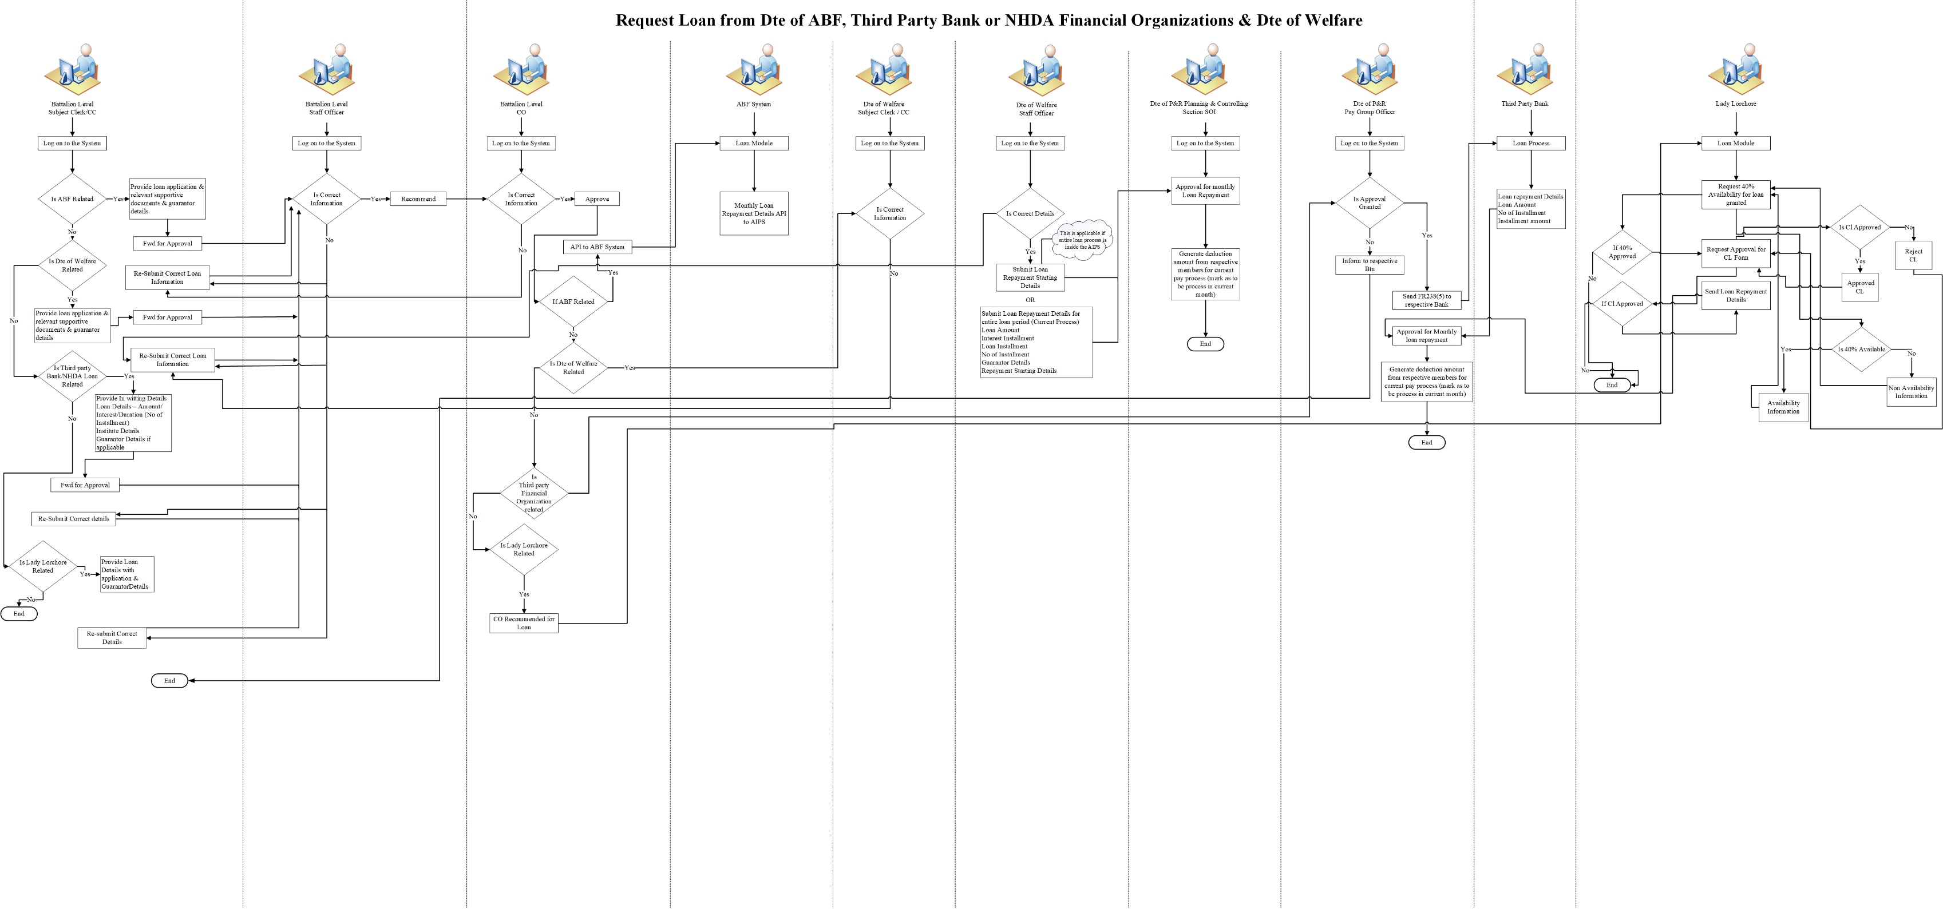

ENTITLE DEDUCTIONS DURING THE TRAINING AND POST-TRAINING/POSTING PERIODS WITH THE RESPECTIVE ENLISTMENT TYPE – FOR OFFICERS

Ser | Enlistment Type | Training Period Related | Posting/ Post Training Period Related
1 | Cadet Entry - KDU | - W&OP  - Religious Fund  - Sports Fund  - Ranaviru Housing Fund  - Mess Bill Deduction  - A B F Savings  - Stamp Deduction  - Suwasahana Insurance Fund  - Sandahiru Stupa  - Multiple Deduction  - Welfare Donation  - Cent Deduction (Balance Cents)  - Ex – Serviceman (one time per annum)  - Death Donation Fund | As described above. (Irrespective of the enlistment type)
2 | Cadet Entry- SLMA | - W&OP  - Religious Fund  - Sports Fund  - Ranaviru Housing Fund  - Mess Bill Deduction  - A B F Savings  - Stamp Deduction  - Suwasahana Insurance Fund  - Sandahiru Stupa  - Multiple Deduction  - Welfare Donation  - Cent Deduction (Balance Cents)  - Ex – Serviceman (one time per annum)  - Death Donation Fund
3 | Direct Enlistment- Officer | - W&OP  - Religious Fund  - Sports Fund  - Ranaviru Housing Fund  - Mess Bill Deduction  - A B F Savings  - Stamp Deduction  - Suwasahana Insurance Fund  - Sandahiru Stupa  - Multiple Deduction  - Welfare Donation  - Cent Deduction (Balance Cents)  - Death Donation Fund  - Ex – Serviceman  - Regimental Death Donation Fund  - Advance Personal Income Tax (If Applicable)
4 | OR Commission | - W&OP  - Religious Fund  - Sports Fund  - Ranaviru Housing Fund  - Mess Bill Deduction  - A B F Savings  - Stamp Deduction  - Suwasahana Insurance Fund  - Sandahiru Stupa  - Multiple Deduction  - Welfare Donation  - Cent Deduction (Balance Cents)  - Ex – Serviceman (one time per annum)  - Death Donation fund  - Regimental Death Donation Fund  - Advance Personal Income Tax (If Applicable)
5 | OR Commission - AMP (Assistant Medical Practitioner) |  | As described above. (Irrespective of the enlistment type)
6 | Call to Army Active Service from Gov. Health Service  (Medical/ Dental Doctors) |  | - W&OP  - Religious Fund  - Sports Fund  - Ranaviru Housing Fund  - Mess Bill Deduction  - A B F Savings (If Request only)  - Stamp Deduction  - Suwasahana Insurance Fund  - Sandahiru Stupa  - Multiple Deduction  - Welfare Donation  - Cent Deduction (Balance Cents)  - Ex – Serviceman  - Death Donation fund  - Regimental Death Donation Fund  - Advance Personal Income Tax (If Applicable)
 | Officers from National Cadet Corps :  1. Call to Army active service from National Cadet Corp |  | - W&OP  - Religious Fund  - Sports Fund  - Ranaviru Housing Fund  - Mess Bill Deduction  - A B F Savings (If requests only)  - Suwasahana Insurance Fund  - Stamp Deduction  - Sandahiru Stupa  - Welfare Donation  - Cents Deduction (Balance Cents)  - Ex – Serviceman  - Death Donation Fund  - Advance Personal Income Tax (if Applicable)  - Loan related Deductions (if Applicable)
7 | 2. National cadet corps service |  | - W&OP  - Religious Fund  - Sports Fund  - Ranaviru Housing Fund  - Mess Bill Deduction  - A B F Savings (If requests only)  - Stamp Deduction  - Sandahiru Stupa  - Welfare Donation  - Cents Deduction (Balance Cents)  - Ex – Serviceman  - Death Donation Fund  - Advance Personal Income Tax (if Applicable)  - Loan related Deductions (if Applicable)
 | 3. National Youth Corps ( yowun senankaya) |  | - W&OP  - Religious Fund  - Sports Fund  - Ranaviru Housing Fund  - Mess Bill Deduction  - A B F Savings (If requests only)  - Stamp Deduction  - Sandahiru Stupa  - Welfare Donation  - Cents Deduction (Balance Cents)  - Ex – Serviceman  - Death Donation Fund  - Advance Personal Income Tax (if Applicable)  - Loan related Deductions (if Applicable)
8 | Civil Doctors (Contract basis) |  | - Stamp Deduction  - Advance Personal Income Tax (if Applicable)  - Cents Deduction (Balance Cents)
9 | Contarct Basis - Officer  1. Already retired Military/ Gov person |  | - W&OP  - Religious Fund  - Sports Fund  - Ranaviru Housing Fund  - Mess Bill Deduction  - A B F Savings (If requests only)  - Stamp Deduction  - Sandahiru Stupa  - Multiple Deduction  - Welfare Donation  - Cents Deduction (Balance Cents)  - Advance Personal Income Tax (if Applicable)  - Loan related Deductions (if Applicable)
 | 2. Person from Government Active service |  | - W&OP  - Religious Fund  - Sports Fund  - Ranaviru Housing Fund  - Mess Bill Deduction  - A B F Savings (If requests only)  - Stamp Deduction  - Sandahiru Stupa  - Multiple Deduction  - Welfare Donation  - Cents Deduction (Balance Cents)  - Advance Personal Income Tax (if Applicable)  - Loan related Deductions (if Applicable)
10 | Call to active service from Regular General reserve |  | - W&OP  - Religious Fund  - Sports Fund  - Ranaviru Housing Fund  - Mess Bill Deduction  - A B F Savings (If requests only)  - Stamp Deduction  - Suwasahana Insurance Fund (If requests only)  - Sandahiru Stupa  - Multiple Deduction  - Welfare Donation  - Cent Deduction (Balance Cents)  - Death Donation Fund  - Loan related Deductions (if Applicable)
11 | Call to active service from Volunteer General reserve |  | - W&OP  - Religious Fund  - Sports Fund  - Ranaviru Housing Fund  - Mess Bill Deduction  - A B F Savings (If request)  - Stamp Deduction  - Suwasahana Insurance Fund (If request)  - Sandahiru Stupa  - Multiple Deduction  - Welfare Donation  - Cent Deduction (Balance Cents)  - Death Donation Fund  - Loan related Deductions (if Applicable)

ENTITLE DEDUCTIONS DURING THE TRAINING AND POST-TRAINING/POSTING PERIODS WITH THE RESPECTIVE ENLISTMENT TYPE – FOR OTHER RANKS

Ser | Enlistment Type | Training Period Related | No Training/ After Training
1 | Recruit | - W&OP  - Religious Fund  - Sports Fund  - Ranaviru Housing Fund  - A B F Savings  - Stamp Deduction  - Suwasahana Insurance Fund  - Sandahiru Stupa  - Multiple Deduction  - Welfare Donation  - Cent Deduction (Balance Cents)  - Ex – Serviceman  - Death Donation Fund | As described in the detailed requirements above. (Irrespective of the enlistment type)
2 | Direct Enlistment - OR | - W&OP  - Religious Fund  - Sports Fund  - Ranaviru Housing Fund  - A B F Savings  - Stamp Deduction  - Suwasahana Insurance Fund  - Sandahiru Stupa  - Multiple Deduction  - Welfare Donation  - Cent Deduction (Balance Cents)  - Ex – Serviceman  - Death Donation Fund  - Regimental Death Donation
3 | Contarct Basis - OR (After Retirement) |  | - W&OP  - Religious Fund  - Sports Fund  - Ranaviru Housing Fund  - A B F Savings  - Stamp Deduction  - Suwasahana Insurance Fund (If request only)  - Sandahiru Stupa  - Multiple Deduction  - Welfare Donation  - Cent Deduction (Balance Cents)  - Loan related Deductions (if Applicable)
4 | Pay and Pension- OR |  | - W&OP  - Religious Fund  - Sports Fund  - Ranaviru Housing Fund  - A B F Savings  - Stamp Deduction  - Suwasahana Insurance Fund (If request only)  - Sandahiru Stupa  - Multiple Deduction  - Welfare Donation  - Cent Deduction (Balance Cents)  - Loan related Deductions (if Applicable)
5 | Militarized - OR | - W&OP  - Religious Fund  - Sports Fund  - Ranaviru Housing Fund  - A B F Savings  - Stamp Deduction  - Suwasahana Insurance Fund  - Sandahiru Stupa  - Multiple Deduction  - Welfare Donation  - Cent Deduction (Balance Cents)  - Ex – Serviceman  - Death Donation Fund  - Regimental Death Donation | As described in the detailed requirements above. (Irrespective of the enlistment type)

Approvals
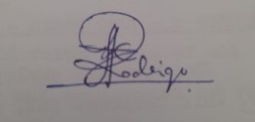  Prepared By  Signature : ………………………………..  Designation : Direct Enlisted IT Officer  Rank & Name : Maj IDC Rodrigo - SLSC  Date : 02/12/2024    Signature : ………………………………..  Designation : Direct Enlisted IT Officer  Rank & Name : Maj CG Hewawasam - SLSC  Date : 02/12/2024 | Approved By  Signature : ……………………………..  Designation : HOW, SD&EW  Rank & Name : Maj BS Dissanayake - SLSC  Date : /12/2024

Requirement Documentation Accepted by Project Owner
Date: ………. / ……….. / ……… | ………………………………………………………......  Signature  Name :  Rank :  Designation :
Requirement Documentation Authorized by Dte of IT
Date: ……… / ……….. / ……… | ………………………………………………………......  Signature  Name :  Rank :  Designation :

